**Tool: Google Cloud AI Platform** 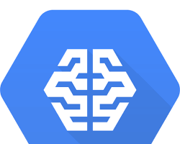

OfficialWebsite:<https://cloud.google.com/vertex-ai/docs/start/introduction-unified-platform>

Purpose:

* A cloud-based machine learning platform from Google Cloud. Google Cloud AI Platform provides a variety of tools for building, training, and deploying machine learning models.